**MEDIUM EDIT DISTANCE**

**PROJECT REPORT**

**Ali Kaan Alboy**

* 1. **Project Content**

In this project, we were asked to integrate or write a program to run a medium edit distance calculating program. Like the first project I decided to code it from scratch to learn and implement the algorithm. The program gives results instantly so I couldn’t add any run time into my report.

* 1. **Project**

The project uses medium edit distance algorithm to search the closest 5 alternative words to it. It has a simple user interface a text box to write your desired word, it works with more than one word as well, and click search button to search it. Below, there is a text area that shows alternative words, their medium edit distance value and for more information it shows medium edit distance matrices for each alternative.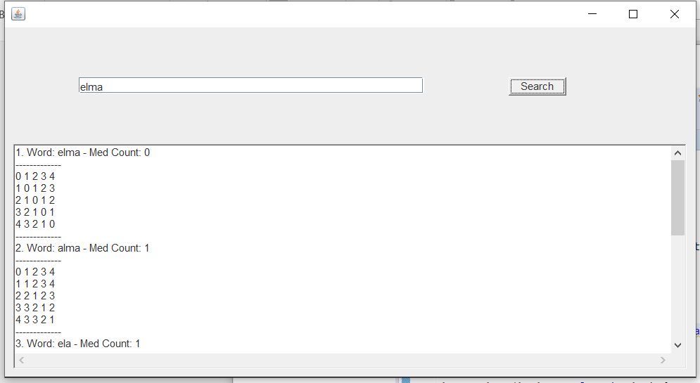

* 1. **Functions**

There is one main and two helping functions that makes this project work. The main function is call MED which takes a String parameter which is the input that has been got from the user. In this function inside a for loop (which’s length is the same with dictionary) and creates the MED matrix according to the upcoming word from matrix. All the words that have less MED values got added into an output array. It also checks if the new word’s MED value is lower than the ones in the output array.

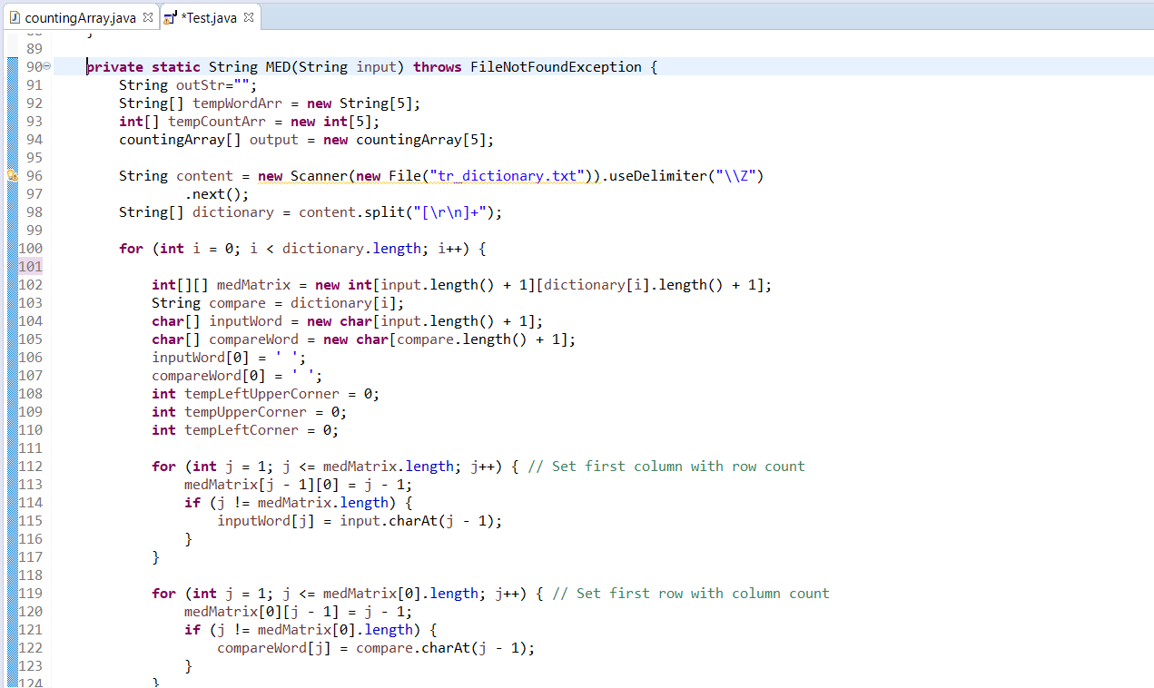

Both of the helping function helps to sort the output array to make it run faster. I initially sort the output array so that last item will become the word that has most MED value. The first helping function sorts only after the first 5 items that gets into output array. The second one starts working after the first 5 elements has been passed.

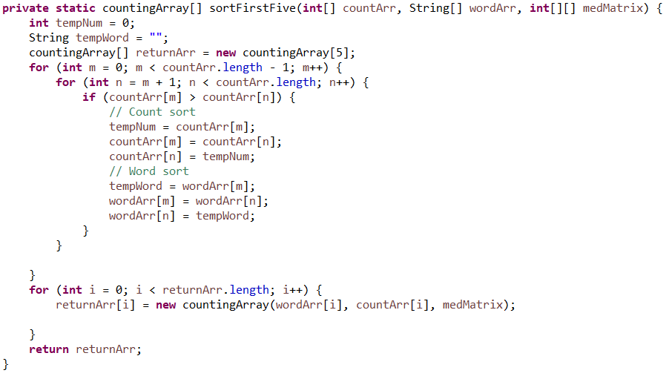

The second helping function runs if the new word has lower MED value than the last output array element to make the program more efficient. If it is it checks the array and pushed last element out and pushes new one and sort the array.

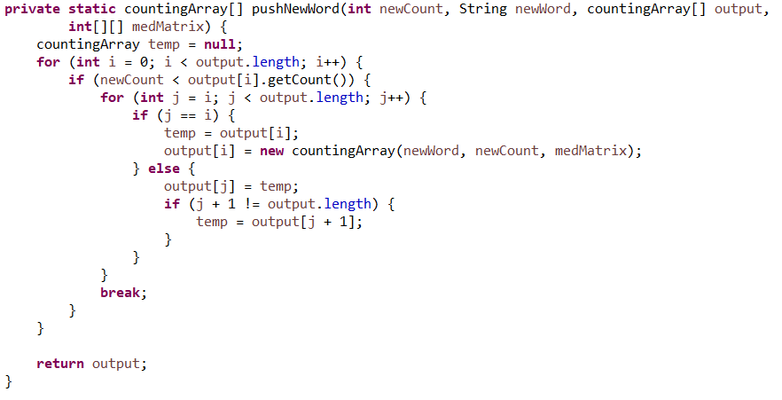

* 1. **Results**

1. Search Word: elma

1. Word: elma - Med Count: 0

-------------

0 1 2 3 4

1 0 1 2 3

2 1 0 1 2

3 2 1 0 1

4 3 2 1 0

-------------

2. Word: alma - Med Count: 1

-------------

0 1 2 3 4

1 1 2 3 4

2 2 1 2 3

3 3 2 1 2

4 3 3 2 1

-------------

3. Word: ela - Med Count: 1

-------------

0 1 2 3

1 0 1 2

2 1 0 1

3 2 1 1

4 3 2 1

-------------

4. Word: elmas - Med Count: 1

-------------

0 1 2 3 4 5

1 0 1 2 3 4

2 1 0 1 2 3

3 2 1 0 1 2

4 3 2 1 0 1

-------------

5. Word: esma - Med Count: 1

-------------

0 1 2 3 4

1 0 1 2 3

2 1 1 2 3

3 2 2 1 2

4 3 3 2 1

-------------

1. Search Word: merhamet

1. Word: merhamet - Med Count: 0

-------------

0 1 2 3 4 5 6 7 8

1 0 1 2 3 4 5 6 7

2 1 0 1 2 3 4 5 6

3 2 1 0 1 2 3 4 5

4 3 2 1 0 1 2 3 4

5 4 3 2 1 0 1 2 3

6 5 4 3 2 1 0 1 2

7 6 5 4 3 2 1 0 1

8 7 6 5 4 3 2 1 0

-------------

2. Word: fehamet - Med Count: 2

-------------

0 1 2 3 4 5 6 7

1 1 2 3 4 4 5 6

2 2 1 2 3 4 4 5

3 3 2 2 3 4 5 5

4 4 3 2 3 4 5 6

5 5 4 3 2 3 4 5

6 6 5 4 3 2 3 4

7 7 6 5 4 3 2 3

8 8 7 6 5 4 3 2

-------------

3. Word: mefharet - Med Count: 2

-------------

0 1 2 3 4 5 6 7 8

1 0 1 2 3 4 5 6 7

2 1 0 1 2 3 4 5 6

3 2 1 1 2 3 3 4 5

4 3 2 2 1 2 3 4 5

5 4 3 3 2 1 2 3 4

6 5 4 4 3 2 2 3 4

7 6 5 5 4 3 3 2 3

8 7 6 6 5 4 4 3 2

-------------

4. Word: mehabet - Med Count: 2

-------------

0 1 2 3 4 5 6 7

1 0 1 2 3 4 5 6

2 1 0 1 2 3 4 5

3 2 1 1 2 3 4 5

4 3 2 1 2 3 4 5

5 4 3 2 1 2 3 4

6 5 4 3 2 2 3 4

7 6 5 4 3 3 2 3

8 7 6 5 4 4 3 2

-------------

5. Word: melamet - Med Count: 2

-------------

0 1 2 3 4 5 6 7

1 0 1 2 3 4 5 6

2 1 0 1 2 3 4 5

3 2 1 1 2 3 4 5

4 3 2 2 2 3 4 5

5 4 3 3 2 3 4 5

6 5 4 4 3 2 3 4

7 6 5 5 4 3 2 3

8 7 6 6 5 4 3 2

1. Search Word: hava

1. Word: hava - Med Count: 0

-------------

0 1 2 3 4

1 0 1 2 3

2 1 0 1 2

3 2 1 0 1

4 3 2 1 0

-------------

2. Word: dava - Med Count: 1

-------------

0 1 2 3 4

1 1 2 3 4

2 2 1 2 3

3 3 2 1 2

4 4 3 2 1

-------------

3. Word: hala - Med Count: 1

-------------

0 1 2 3 4

1 0 1 2 3

2 1 0 1 2

3 2 1 1 2

4 3 2 2 1

-------------

4. Word: hara - Med Count: 1

-------------

0 1 2 3 4

1 0 1 2 3

2 1 0 1 2

3 2 1 1 2

4 3 2 2 1

-------------

5. Word: hasa - Med Count: 1

-------------

0 1 2 3 4

1 0 1 2 3

2 1 0 1 2

3 2 1 1 2

4 3 2 2 1

-------------

1. Search Word: su

1. Word: su - Med Count: 0

-------------

0 1 2

1 0 1

2 1 0

-------------

2. Word: Asu - Med Count: 1

-------------

0 1 2 3

1 1 1 2

2 2 2 1

-------------

3. Word: Hu - Med Count: 1

-------------

0 1 2

1 1 2

2 2 1

-------------

4. Word: se - Med Count: 1

-------------

0 1 2

1 0 1

2 1 1

-------------

5. Word: sı - Med Count: 1

-------------

0 1 2

1 0 1

2 1 1

-------------

1. Search Word: toprak

1. Word: toprak - Med Count: 0

-------------

0 1 2 3 4 5 6

1 0 1 2 3 4 5

2 1 0 1 2 3 4

3 2 1 0 1 2 3

4 3 2 1 0 1 2

5 4 3 2 1 0 1

6 5 4 3 2 1 0

-------------

2. Word: topak - Med Count: 1

-------------

0 1 2 3 4 5

1 0 1 2 3 4

2 1 0 1 2 3

3 2 1 0 1 2

4 3 2 1 1 2

5 4 3 2 1 2

6 5 4 3 2 1

-------------

3. Word: torak - Med Count: 1

-------------

0 1 2 3 4 5

1 0 1 2 3 4

2 1 0 1 2 3

3 2 1 1 2 3

4 3 2 1 2 3

5 4 3 2 1 2

6 5 4 3 2 1

-------------

4. Word: çaprak - Med Count: 2

-------------

0 1 2 3 4 5 6

1 1 2 3 4 5 6

2 2 2 3 4 5 6

3 3 3 2 3 4 5

4 4 4 3 2 3 4

5 5 4 4 3 2 3

6 6 5 5 4 3 2

-------------

5. Word: çorak - Med Count: 2

-------------

0 1 2 3 4 5

1 1 2 3 4 5

2 2 1 2 3 4

3 3 2 2 3 4

4 4 3 2 3 4

5 5 4 3 2 3

6 6 5 4 3 2

-------------